**Digital Media – Identifying Camera Formats**

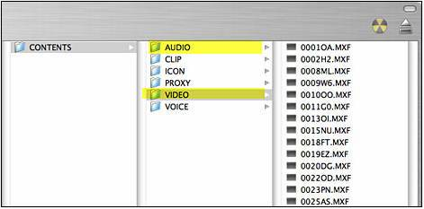File Format: **Panasonic P2**

Process: Final Cut Pro (Log and Transfer)

FCP Plugin Required: P2 AVC-Intra

Notes:

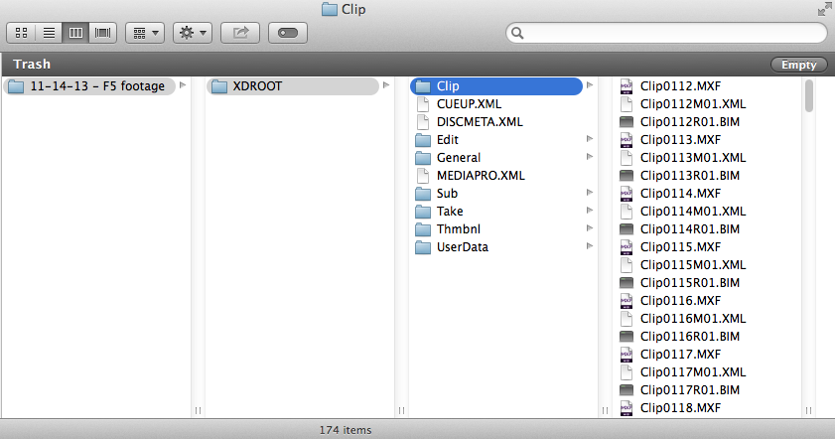File Format: **Sony XDCAM HD**

Process: XDCAM Transfer

Final Cut Pro (Log and Transfer)

FCP Plugin Required: PDZK-LT1

Notes: Sony F5 and F55 have similar folder structures. Main difference is clip naming convention.

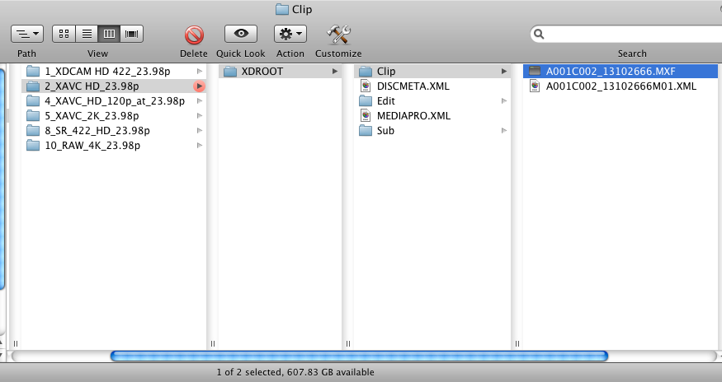File Format: **XAVC Intra HD**

Process: Avid Media Composer 6

Avid Plugin Required: PDZK-MA2

Notes: Sony F5 and F55 have similar folder structures. Main difference is clip naming convention.

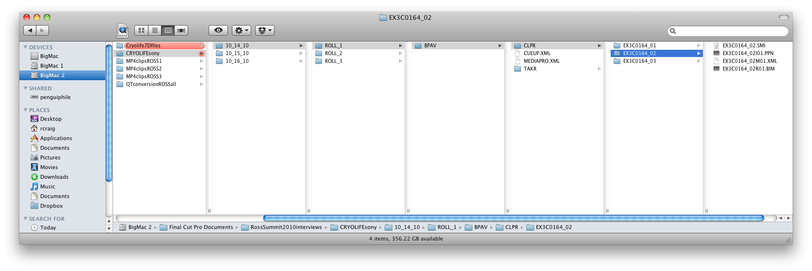File Format: **Sony XDCAM EX**

Process: XDCAM Transfer

Final Cut Pro (Log and Transfer)

FCP Plugin Required: PDZK-LT1

Notes:

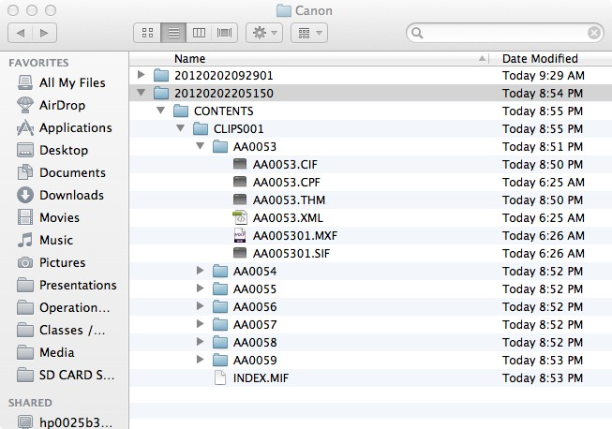File Format: **Canon C300**

Process: Final Cut Pro (Log and Transfer)

FCP Plugin Required: Canon XF Plugin

Notes:

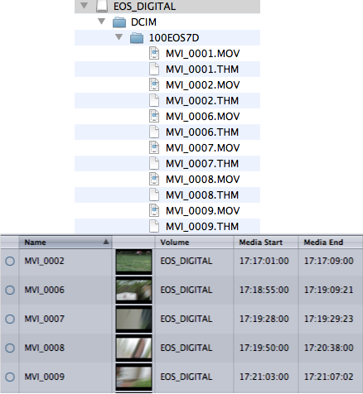File Format: **Canon 5D/7D**

Process: Final Cut Pro (Log and Transfer)

MPEG Streamclip

FCP Plugin Required: EOS Movie Plugin E1

Notes:

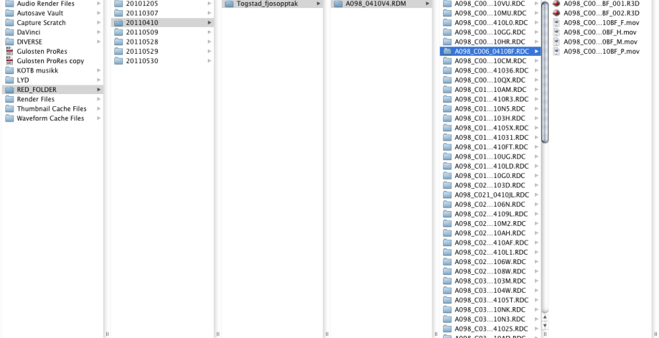File Format: **Red**

Process: Final Cut Pro (Log and Transfer)

FCP Plugin Required: REDCODE

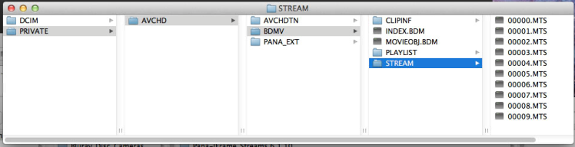File Format: **AVCHD**

Process: Final Cut Pro (Log and Transfer)